Operating system concepts and networking management
Total Marks: 100
Time: 3 hours
No. of Questions: 5

- What
- Where use
- Problem kya solve karta h
- User se relate
- Example
- Real world example
- Security
- Cost

LINUX COMMANDS
Linux@Ankit
Linux -> domain host
Ankit -> Host name
- Cmp : Do files ko compare karta hai aur unke beech ka farq batata hai.
- some_command | tee output.txt - kisi command ka output terminal par dikhata hai aur file mein save karta h
- /temp - temporary files
- /etc - configuration files
- /bin - basic programs, ls cd mv etc
- help - show commands and their use
- man - command ya program ka complete manual batata h
- Ls / dir - directory k saare files aur folders dikhata h
- ls ??? - To list all the files in a directory that have 3 characters in the file name:
- cd - change directory ( ek folder se dusre folder me change )
- mkdir - create new directory
- netstat- jo network connections aur port status jaise network-related details dikhata h
- cp - copy a file or folder, cp file1.txt /home/user/Documents/
- mv - move or rename file or folder
- rm - remove or delete file or folder
- sudo su - grant permission priviliges
- cat - file k content dikhata h
- nano - linux file editor
- gedit - file editor software
- ./, bash - execute shell file
- apt-get update - update package list (URL's), self update like playstore
- apt-get upgrade - update all installled softwares
- apt-get install git - install a particular software
- Head : File ke starting ke 10 lines dikhata hai.
- Tail : File ke last 10 lines dikhata hai.
- Chmod : File ke permissions (read, write, execute) badalne ke liye.
- chmod 777 ABC - To set file permissions of a file ABC to read, write, and execute
- Grep : Kisi word ya pattern ko search karta hai file mein., "text" file (text dhoondho).
- PWD : Bataata hai ki aap kis folder mein ho.
- Kill <PID> : Process (program) ko band karne ke liye.
- PS : Chal rahe processes (programs) ki list dikhata hai.
- WC : Words, lines aur characters count karta hai.
- Tree : Folder aur uske andar ka structure tree jaisa dikhata hai.
- /home - home directory of super user (admin)
- ls -a - List all hidden files in a directory:
- Top, htop - List all processes currently running on the system:
- chmod 400 sample.txt Set permission to a file, say sample.txt, so that the file can
- tail -n 10 <filename> Print the last 10 lines of a file:
- Who - Show all users currently logged on:
- Touch - file.txt nayi file
- find / -name "file.txt" - (file search), To search and locate a file based on the owner
- df -h - Space Check: (disk space)
- *du -h dir (folder ka size).
- tar -cvf archive.tar dir (pack karo)
- tar -xvf archive.tar (kholo).
- Lpr - To print the contents of a file using the line printer
- Passwd - To change the password
- at 10:00 - To execute a command at a given time

COMPONENTS OF LINUX OS
Environment - G nome Desktop
Some Number of distros :
Ubuntu, Devian, Kali Linux, Black arch, Red hat, Fedora, Linux mint, manjarono, elementary OS, zorin OS, etc
1. Kernel, Initialization System (Starter): System start hone ke baad sab services aur processes start hote h
2. File System
3. CLI, Shell(terminal)
4. User Applications (Software), System Utilities (Daily Tools): ls, cp, top, System Libraries (Helper Tools)
5. Device Drivers (Hardware Connectors)

TFTP (Trivial File Transfer Protocol)
- TFTP kisi network par files ko ek device se doosre device par bhejta h.
- TFTP ek network protocol hai
- TFTP par Files download ya upload kar sakte hai.
- TFTP ki speed zyada fast hai, lekin reliable nahi.
- TFTP ki security weak hoti h, no password, no encryption. Public network pe safe nahi h, outdated
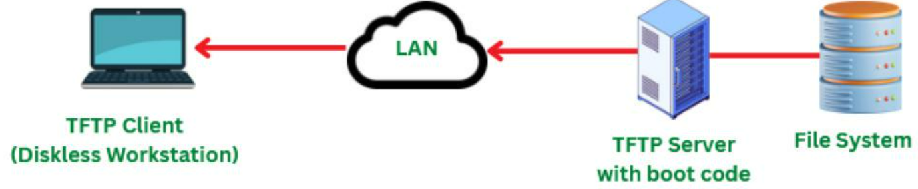
TELNET
- telnet ek network protocol hai
- Apne computer se dusre remote computer ko command-line ke through access aur control karte h
- Telnet se remote server par login karte h
- security weak hai kyunki Data ko plain text mein bhejta hai isliye ab SSH use hota hai.
- Ex. putty, Dono purane ho gaye hain
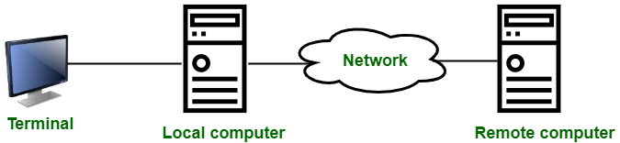

Define authentication tokens. With reference to authentication tokens, explain the use of Hardware tokens and Software tokens.
Authentication Tokens
Authentication tokens user ki pehchaan (identity) verify karta h.
AT user ka system ya account ko secure banata h
AT se sirf sahi user login karta h unaurthorized person nhi
Hardware Tokens
- Hardware tokens ek chhoti physical device hoti hai
- HT user ki identity confirm karta h aur login karta h
- Ex. Fingerprint sensor
Software Tokens
- Software tokens apps hote hain (jaise Google Authenticator)
- ST time ke saath badalne wale code banate hain.
- ST codes user k account ko login aur access karta h.
- Ex. Authenticator apps
Yeh dono tokens account ko secure banate hain –
ek physical device ke through, aur dusra app ke through
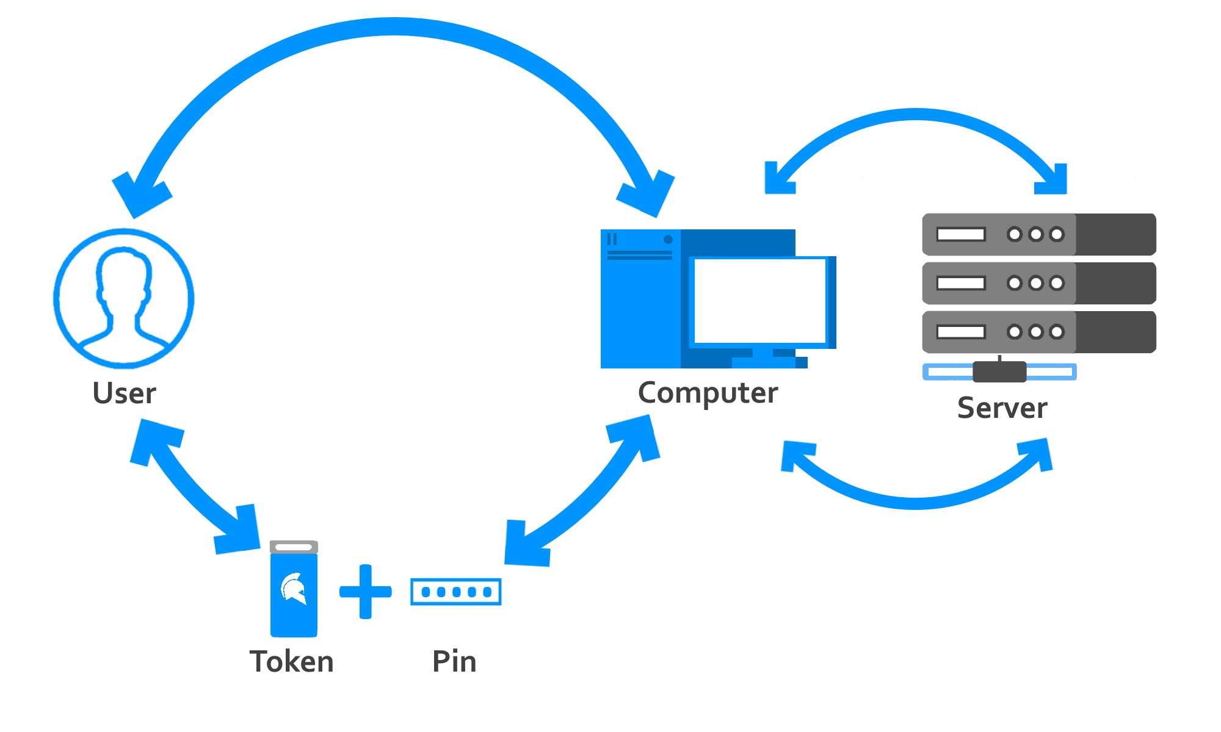

*Elucidate the following with reference to Windows XP Networking:
(i) TCP/IP Protocol settings
(ii) VPN and Remote Networking facilities
*TCP/IP (Transmission Control Protocol / Internet Protocol) —
- Ek network protocol hota hai
- Tcp / ip internet aur network communication ka basic rule hai.
- Tcp / ip data ko safely ek device se dusri device tak transfer karta
- tcp data ko reliable transmit karta hai,
- TCP/IP local device ko network aur internet se connect karta hai
- TCP/IP Settings change karne k liye control panel me jaate h
Do tarike se settings set kar sakte ho manual and automatic
Automatic me local ip address khud set karta h
Manual me IP address: 192.168.1.10
      - Subnet mask: 255.255.255.0
      - Gateway: 192.168.1.1
      - DNS: 8.8.8.8 se karna padta h
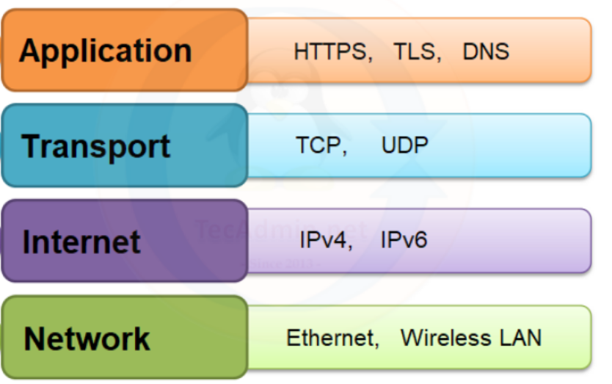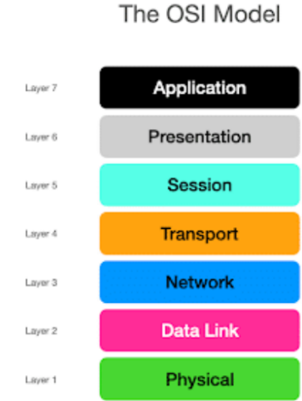

What is security breach in computer system? Classify various types of security breach and explain
- jab hacker ya koi anonymous bina permission ke kisi computer system ya network me ghus jata hai aur data chura leta hai ya system ko nuksan pahunchata h
- Security breach se bachne ke liye strong passwords, antivirus, firewalls, aur multi-factor authentication ka use karte h
- Ex. yahoo biggest data breaches
Security Breach ke Types:
- Password Attack – Weak password tod kar unauthorized access karna
- Malware Attack – Virus ya ransomware software system ko damage kar dete hain.
- Phishing –
- SQL Injection – Website ke database me ghuskar important data chura liya jata hai.
- Insider Threat –.
- Zero-Day Exploit – Software ke naye bugs ka faayda uthakar system hack karna
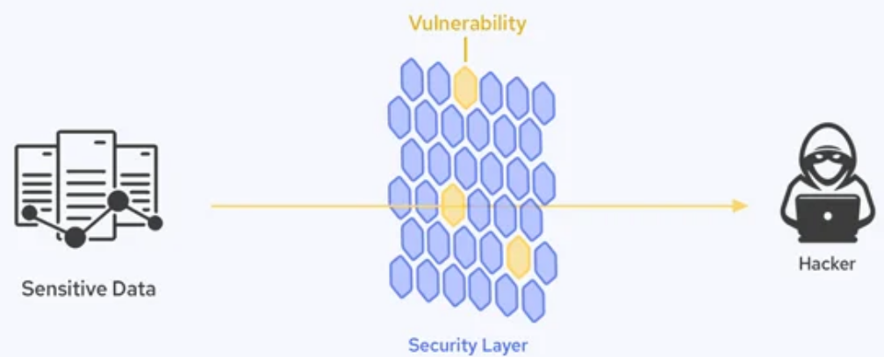

Briefly explain services of Windows 2000 server.
Windows 2000 Server ke main services:
- Active Directory – Users aur computers ka management hota h
- File sharing
- Print Services
- Remote Access
- Security
- Authentication
- Terminal Services
- DFS (Distributed File System)
- DNS, DHCP, WINS – Network ke liye address aur name management hota h


HOME DIRECTORY IN LINUX
- Linux system mein Home Directory default jagah hoti hai
- Home Directory har user k personal files, configurations, aur settings store karti hai.
- Home Directory /home folder ke andar hoti hai
- Home directory me ek se jyaada user add kar sakte h aur har user ke liye alag hoti h
- Ex : Agar ek user ka naam ankit hai, toh uski home directory hogi:
/home/ankit - Yahan par uske documents, downloads, aur personal files rahengi
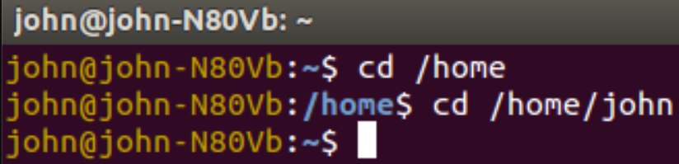

FIREWALL
Firewall
- Firewall data, computer aur network ko safe aur secure rakhta hai
- Firewall Unauthorized, Hackers, Aur Virus se bachata h
- Firewall Rules Banata h : Sirf certain apps ya websites ko access deta h
- EX. NETGUARD, AFwall
*Firewall Kaise Kaam Karta Hai?
- Filter Traffic : Firewall data ko filter karta hai kaunsa data aana ya jaana chahiye
- Keep Connections Track: firewall Active connections ko monitor karta hai
- Data check : firewall Data packets ko andar aane se pehle scan karta hai.
- Hide IP Address : firewall Computer ka real IP address attackers se chhupata h
Firewall Ki Limitations
- internal Threats pakad nhi sakta : Apne network ke andar problem ho, toh firewall help nahi karega.
- Advanced Attacks rok nhi sakta : Bhot complicated attacks ko block nahi kar sakta
- Slow hota h: Agar zyada traffic ho, toh performance thodi slow ho sakti hai.
- Rules par Depend h : Galat settings se problems ho sakti h
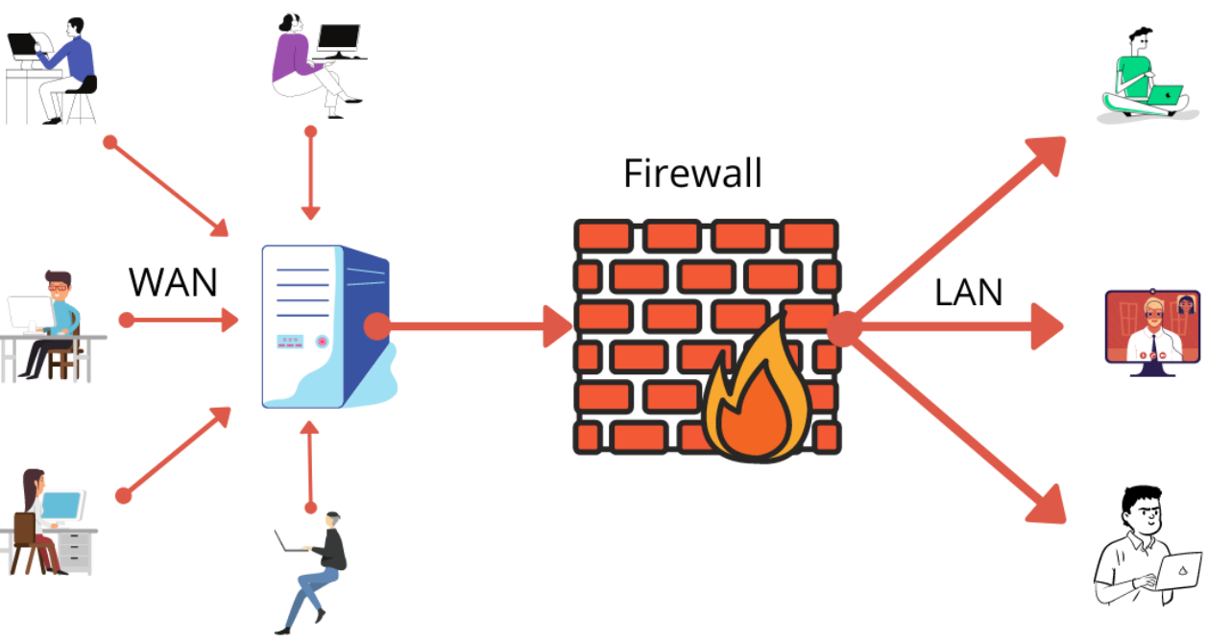

List and discuss the pre-installation checks to be done before installing LINUX
System Requirements Check
Hardware Compatibility
Backup Existing Data
Partition Planning
Check Boot Mode (BIOS/UEFI)
Create Bootable Media
Driver Availability
Security and Firmware

FAT 32, FAT 16, NTFS FILE SYSTEMS IN WINDOWS 2000
FAT16 aur FAT32 ke beech farq
FAT16
- 2 GB tak ki file support karta h
- 2 GB tak Volume Size support karta ha
- Cluster Size mein Zyada space waste karta ha
- bade drives par Slow hota hai
- Data ka backup nahi hota
- Purane OS jaise MS-DOS support karta h
FAT32
- 4 GB tak ki file support karta h
- 2 TB tak volume size support karta hai
- Cluster Size mein Kam space waste karta hai
- bade drives par Fast hota hai
- Data ka backup hota ha
- Naye OS jaise Windows 98
NTFS ke Features (Windows 2000 OS ke context mein)
- Large Drives:
  - Bahut bade drives (16 exabytes tak) ko handle kar sakta hai.
- Extra Metadata:
  - Files ke saath extra information store kar sakte ho.
- Security:
  - Files aur folders ko lock kar sakte ho.
  - Encryption ke through data safe hota hai.
- Fast Search:
  - Files ko jaldi search karne ke liye indexing karta hai.
- Old Systems Support:
  - Purane systems NTFS ko read-only mode mein access kar sakte hain.
- Reliable
  - Agar system crash ho jaye, toh data safe rehta h
  - Errors apne aap fix kar leta hai.
- Disk Quotas:
  - Kisi user ke liye storage limit set kar sakte ho
- Compression:
  - Files aur folders ko chhota karne ka option hai, taaki space bache.
EX. HARDDRIVE, SSD
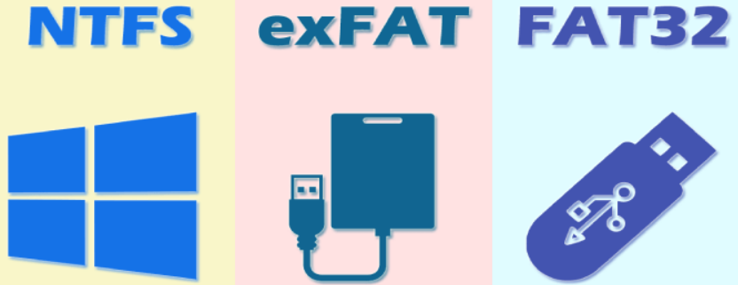

X WINDOWS FEATURES
X-Windows
ek graphical user interface (GUI) system hai
jo Unix aur Linux par graphical applications ko show karta h
X windows screen par windows, buttons aur graphics dikhata h
- *Client-Server Model:
X-Windows me (client) aur (server) dono alag hote hain.
X-Windows me application aur display system dono alag hote hain.
Matlab ek computer par application chalti hai aur doosre par dikti hai.
- Network Support:
X-Windows ko remote computers par bhi use kiya ja sakta hai.
- Customization:
Isme user apna window manager (GNOME, KDE, i3, etc.) choose kar sakta hai.
- Multi-User Support:
Ek system par ek saath multiple users kaam kar sakte hain
- Security:
X-Windows remote access ke liye authentication aur access control features deta h
Rest GUI
- X-Windows me pura control user ke paas hota hai.
- X-Windows network pe remote GUI par chalane ka built-in support deta hai,
- X-Windows me window manager aur looks change kar sakte ho
- Windows/macOS ka fixed GUI hota h
- Windows/macOS me alag software chahiye hota h
- Windows/macOS ka UI ek hi jaisa rehta h
Ex. 💻 Windows 11, Windows 10, Windows 8, Windows 7, XP, etc.
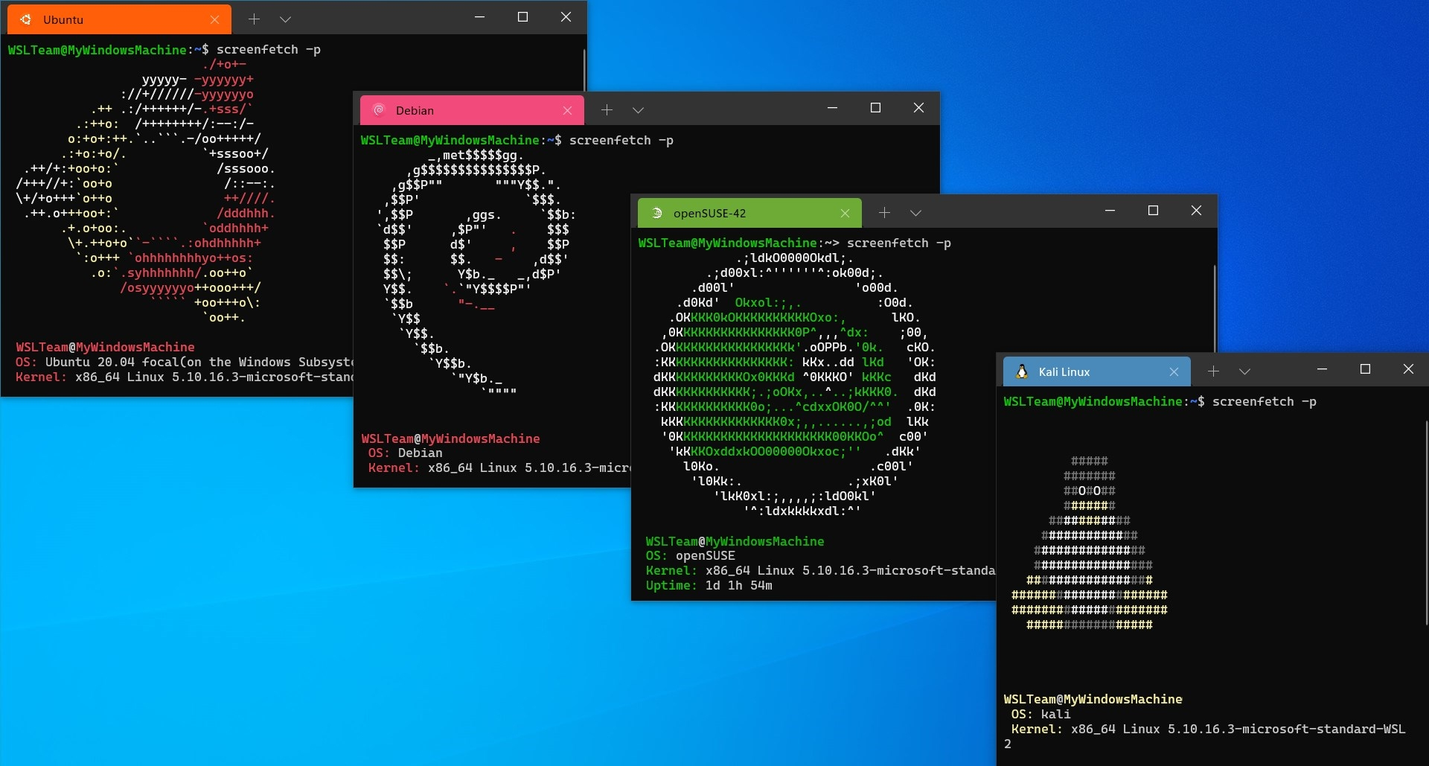

X-Windows Parts
- X-Windows ek (GUI) system hai
- X windows Unix aur Linux par gui applications ko display karta h
- X windows screen par windows, buttons aur graphics dikhata h
- Ex. Linux distributions Ubuntu BSD systems, Solaris
X-Windows ke main parts:
- X Server :
  - X server Display aur input devices (keyboard aur mouse) ko control karta h
- X Client :
  - Applications (jaise browser ya text editor) jo X Server se screen par cheezein dikhane aur kaam karne ki help lete hain.
- Window Manager:
  - Windows ka size, position aur look control karta hai.
  - Example: GNOME, KDE, XFCE.
- Toolkit Libraries:
  - Ready-made buttons, sliders aur menus banane ke liye tools provide karta h
  - Examples: GTK+ aur Qt
- Protocol:
  - X Server aur X Client ke bich ka connection kese chalega yeh define karta h

Packet Switching
1. Packet switching me data ko chhoti-chhoti parts (packets) me tod kar bheja jata hai.
2. Har packet apne raste se jaata hai
aur destination par pahunch kar wapas jod diya jata h
Packet Switching Types: Difference
Datagram
- Connectionless hota hai.
- Har packet alag rasta choose karta hai.
- Reliable nahi hota
- Example: IP (Internet)
- Ise network layer mein implement Kiya jata h
Virtual circuit
- Connection-oriented hota hai.
- Pehle path fix hota hai, sab packets wahi se jaate hain.
- Reliable hota hai.
- Example: Telephone call, ATM network.
- Ise data link mein implement Kiya jata hai
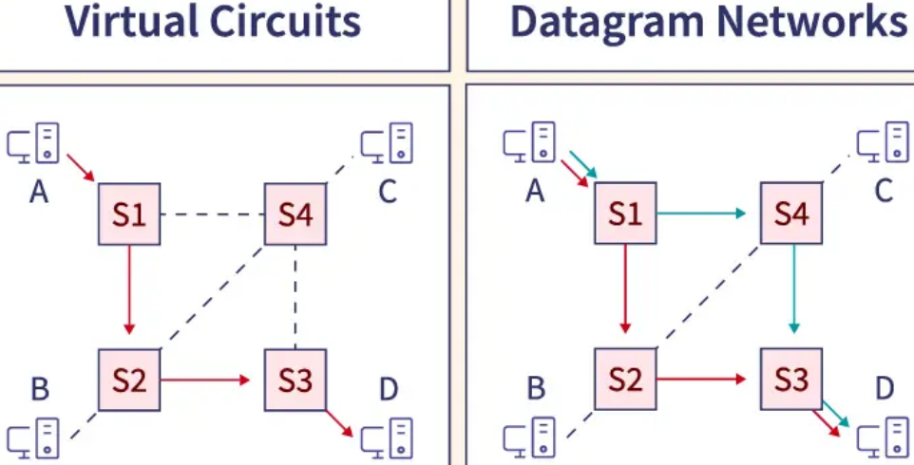

POP3, IMAP, SNMP PROTOCOLS
POP3 (Post Office Protocol 3)
- Emails server se download hote hain.
- Download ke baad server se delete ho sakte hain.
- Sync nhi hota : Ek hi device se access easy hota hai
- Offline access easy hota h
- Simple aur kam server space use hota ha
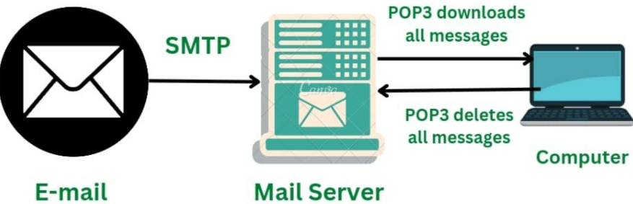
IMAP (Internet message access protocol)
- Emails server par hi store rehte hain
- Server par safe rehte hain jab tak manually delete na karein.
- Sync hota h: Multiple devices se access kar sakte ho.
- Internet connection zaroori hota hai (mostly)
- Server par zyada space lagta h
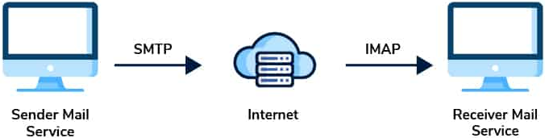
SNMP (Simple Network Management Protocol) —
- ek protocol hai
- snmp network devices jese routers, switches, printers ko monitor aur manage karta h
- Snmp se network administrator devices ki health, performance aur status ko remotely check kar sakta h
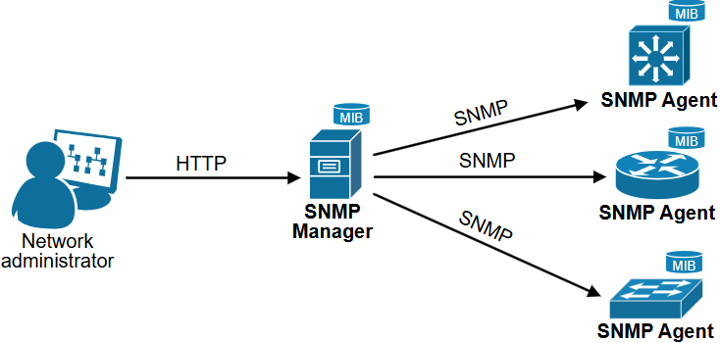
Transmission Media Types: -
- Guided Media: data cables ke through transfer karta hai.
Example: twisted pair cable, coaxial cable, optical fiber.
- Unguided Media: data hawa ke through travel karta hai bina kisi cable ke.
Example: radio waves, microwaves, infrared.
Unguided Media
Fayde: Long distance, Easy to install, without wire, affordable cost
Nuksan: Signal interference, weak Security, easily hack
Optical Fiber
Optical fiber ek special cable hai jisme data light ke form mein travel karta h
Iske parts: 1. Core: Jisme light chalti hai.
2. Cladding: Light ko bahar jaane se rokti hai.
3. jacket: Cable ko protect karta hai.
Fayde: Fast speed, Long-distance, Not latency, Secure h
Nuksan: Expensive, easily broken, maintenance
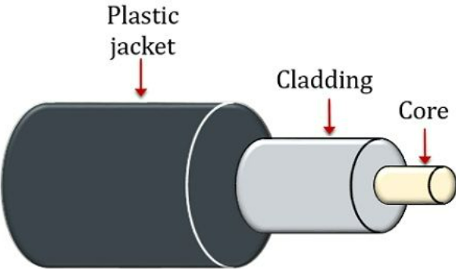

Network Topology and Computer Network
- devices ke arrangement ko describe karta hai
ek network k process ke arrenagment ko describe karta h
- Kaise ek device dusre devices se connected hota h
- Types - 7 line, Star, Ring, Bus, Mesh, Tree, Hybrid Topology
For Each Topology
- har device apne nighbours se directly connected hote h
- har device apne aas paas k neighbours se directly communicate karte h
- aur information kha se kha tak konsi direction me flow hoti h
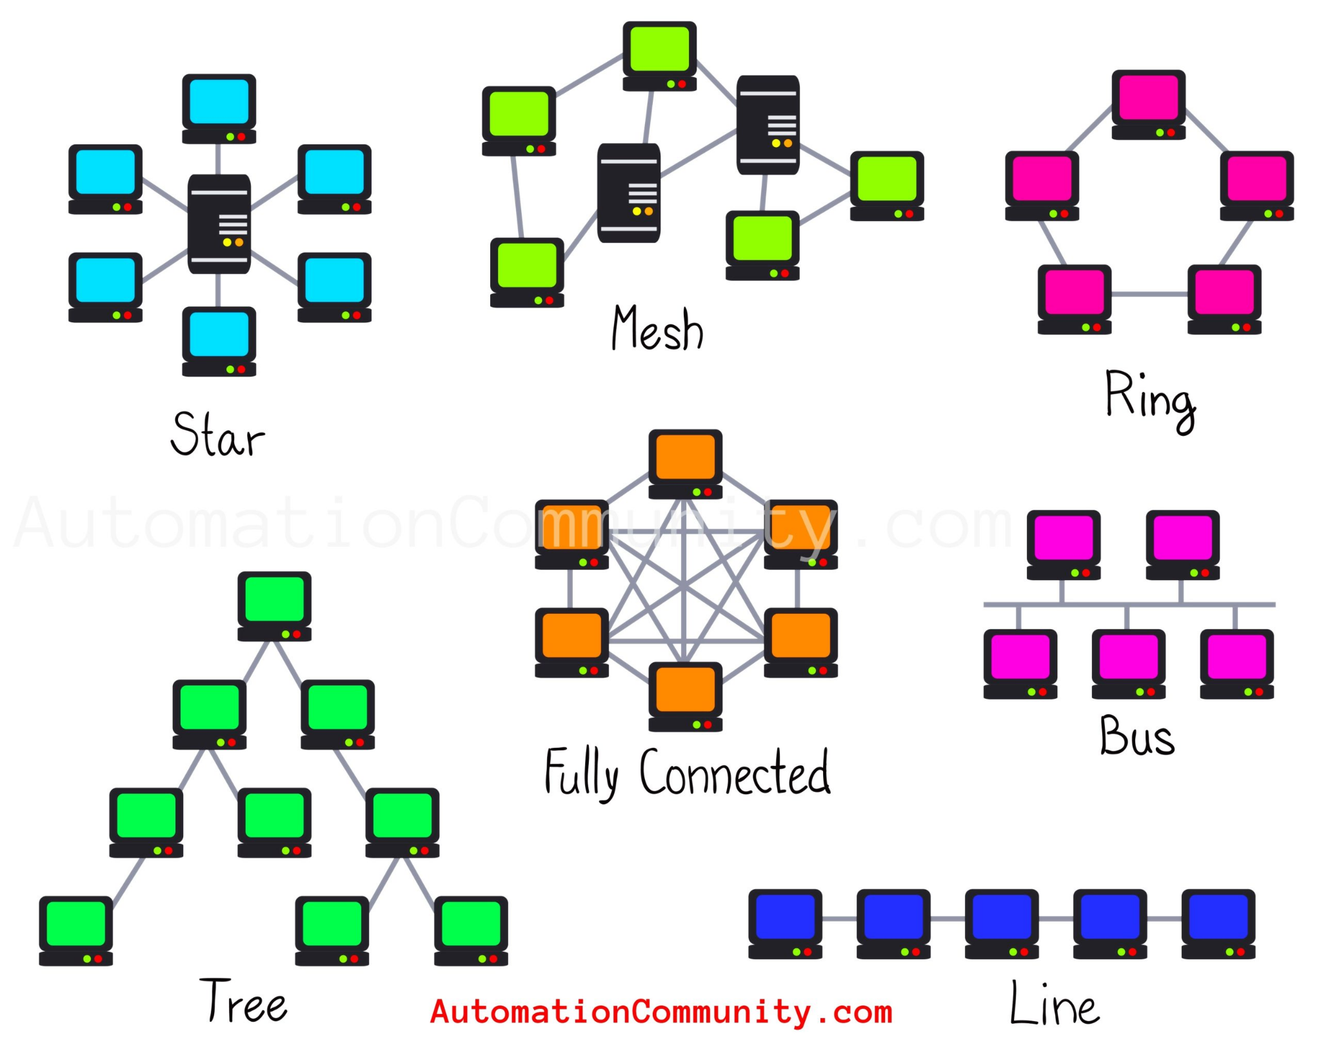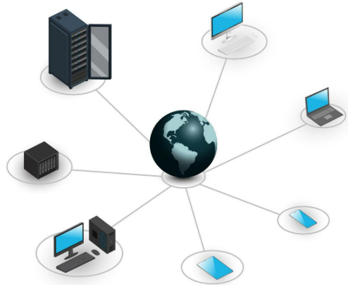
computer network k advantages
high speed, low cost, Data Sharing and Communication, storage capacity, Remote Access

Explain the various user authentication methods in computer system.
User Authentication Methods :
- Token Authentication: Ex. sms, otp
- Single Sign-On (SSO): Ex. pattern, pin lock
- CAPTCHA Ex. Images identify karna, puzzles solve karna
- Security Questions Ex: "Aapki first school ka naam kya tha?"
- Password Authentication Ex. login page, username with password
- Two-Factor Authentication (2FA): Ex. google authenticator,
- Multi-Factor Authentication (MFA) ex. Password, Smart card, Fingerprint
- Voice Recognition Ex: google assitant, alexa
- Biometric Authentication: fingerprint, face lock
- Smart Card Authentication: metro card, identity card
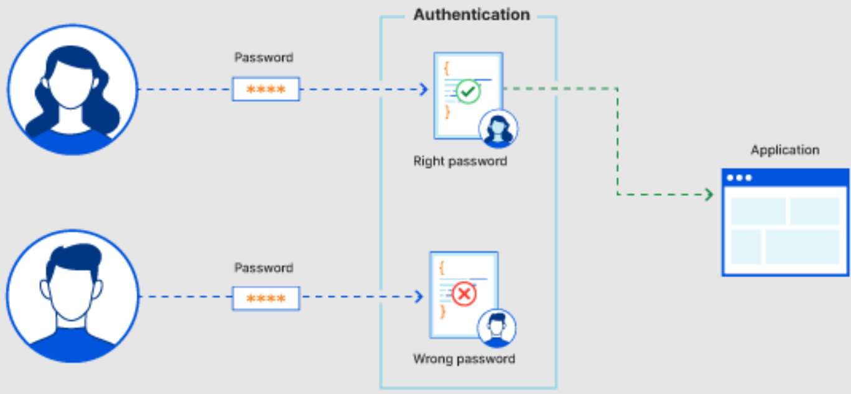

Symmetric vs Asymmetric Cryptography
Symmetric
- Ek hi key encrypt aur decrypt karne ke liye hoti hai.
- Speed Fast hota hai
- Ex. Data files, VPN secure karna
- RWEx. ek key se taala khol sakte h aur laga sakte h
- Security - weak beacause of single key
Asymmetric
- Encrypt ke liye public key aur decrypt ke liye private key hoti h
- Speed - slow
- Ex. Digital signature aur secure emails.
- RWEx. ek key se taala khol sakte h dusri key se taala laga sakte h
- Security - high beacause of double keys
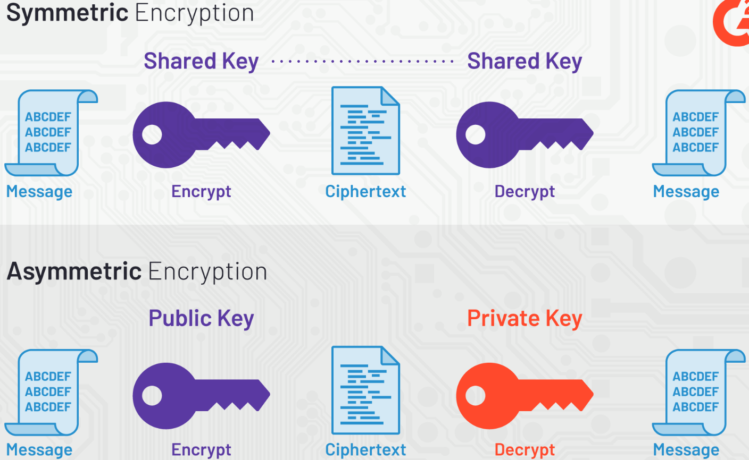

Computer Security Classification
- Csc ek system hai jo data ko secure rakhta h
- Csc unauthorized access aur threats se bachata h
- Csc Privacy aur security banaye rakhta h
Classification Levels (Categories)
- Public (Sabke Liye):
  - Example: Press releases, advertisements.
- Sensitive (Private):
  - Example: Company ke internal emails
- Confidential (Important):
  - Example: Employee ki salary ya personal details
- Secret (Bahut Important):
  - Example: Military plans, government projects
- Top Secret (Sabse Zyada Important):
  - Example: Nuclear codes, spy information
Security Ke Rules
- Confidentiality, Integrity, Availability
Security Measures (Data Ko Kaise Bachate Hain)
- Physical Security, Network Security, Data Encryption, User Authentication

DNS DOMAIN NAME SYSTEM
1. DNS ek internet protocol hai
2. DNS domain names ko IP addresses mein convert karta hai aur iska oolta bhi karta h
3. DNS internet पर websites को identify करनेवाले unique name hota h
4. Ex. domain name - google.com, IP addresses - 172.217.164.78
*DNS server kaam kaise karta hai
1. Browser mein website ka naam type karte h
2. Browser website ka IP address dhoondta h
3. Agar IP address nahi milta, to Browser DNS server se poochta hai.
4. aur fir DNS server root, TLD, aur authoritative server se poochta hai.
5. Authoritative server se IP address milta hai.
6. IP address milne par browser website ko load karta h
DNS ke Design Goals (Maqsad) / Design Principles
- Scalability – DNS internet ke saare domain names ko handle karta h.
- Reliability – DNS Hamesha kaam karta h, chahe kuch servers down ho jaayein.
- Performance – DNS Fast response deta h, jab bhi user koi website access kare.
- Distributed Management – Saara data ek server pe nahi, alag-alag servers me divide hota h
- Security – DNS spoofing attacks se bachata h aur data safe rheta h
Components :
1. Client Request 2. Local DNS Cache 3. DNS Resolver 4. Root Server Query 5. TLD Server Query 6. Authoritative Server Query 7. Response to Client 8. Caching
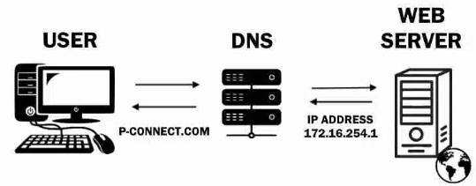

Operating System (OS)
- operating System ek software hai
- os hardware aur user ke beech ka bridge banata h
- os applications ko chalane ki permission deta hai.
Operating System ke Features
- Memory Management, File Management, Device Management, Process Management, Multi-tasking, Multi-user, Security
Operating System ke Components (Parts):
- Kernel, File System, User Interface, Device Drivers, Shell, System Utilities
Os types :
Multiprocessing OS
- ek system me ek se zyada task ke process ek saath excute hote h
- system ki speed aur performance badhata h.
- Ex. multi-core processor in your pc (jaise Intel i5, i7, AMD Ryzen)
Distributed OS
- Ek system me ek se jyaada computers ek saath jud kar ek single system ki tarah kaam karte h
- Har ek pc CPU, memory dusre pc ko share karta h
- Aur machines add kar sakte ho easily.
- Ex. making super computer through graphics card
Network OS
- network devices aur data ko manage karta hai.
- Clients server ke beech communication aur sharing karta h
- Share email, Files, printers
- Zyada log connect ho sakte hain, par limited hai.
Multithreading
- ek single process ke andar multiple threads (small tasks) ek sath execute hote h
- system ki efficiency ko badhata hai
- aur programs ko fast aur smooth banata hai.
- ek restaurant mein ek waiter jo ek time par kai tables ki order le raha ho, bill de raha ho, aur food serve kar raha ho, bina rukhe kaam karte hue.
Multiprogramming OS
- Ek system me multiple programs ek saath execute hote h
- Jab ek program ka cpu process rukta h tab dusra program ka cpu process use hota h
- Mos se computer fast aur efficient kaam karta h
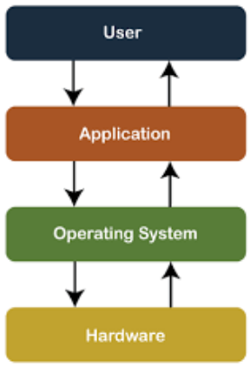

*Osi model
1. open system interconnection model
2. Yah Ek conceptual framework hai ya protocol h
3. ye communication protocols ko 7 Leyers me organised karta h
4. Computer system mein data ko exchange karta h
5. Osi model mein Sevan layers hote Hain
- Physical Layer: main- data for each layer
- Data Link Layer:
- Network Layer:
- Transport Layer:
- Session Layer:
- Presentation Layer:
- Application Layer:
Describe domains, workgroups and trusted relationship in terms of Windows 2000
🖥️ Domain (Windows 2000):
- Ek bada network hota h
- sab computers ek server ke through control hote hain.
- user kisi bhi computer se account banata hai aur kahin se bhi login kar sakta h
- Ex. Large office ya company ke liye perfect
💻 Workgroup:
- Ek Chhota network hota h
- har computer apne aap ka boss hota hai.
- User Har computer pe alag alag account banata h
- Ex. Small office ya ghar ke liye best.
🔗 Trusted Relationship:
- do alag Domains ek dusre pe trust karte hain.
- Ek domain k comp’s dusre domain k comp par trust karte h
- User ek domain k computer par account banata h aur dusre domain se bhi access kar sakta h
- Badi company me useful hota h

Virtual Private Network.
- VPN internet connection ko safe aur private rakhta hai.
- VPN se data secure rehta hai,
- VPN se IP address (location) track nahi hota.
VPN ka use
- Public Wi-Fi pe safe rehne ke liye.
- Blocked websites ya apps access karne ke liye.
- Aapke online identity ko private banane ke liye.
VPN ki Security ke Fayde
- Safe Data
- Safe Connection
- Hide IP Address
- Protect on Public Wi-Fi
- Access Blocked Content
- Data not Change
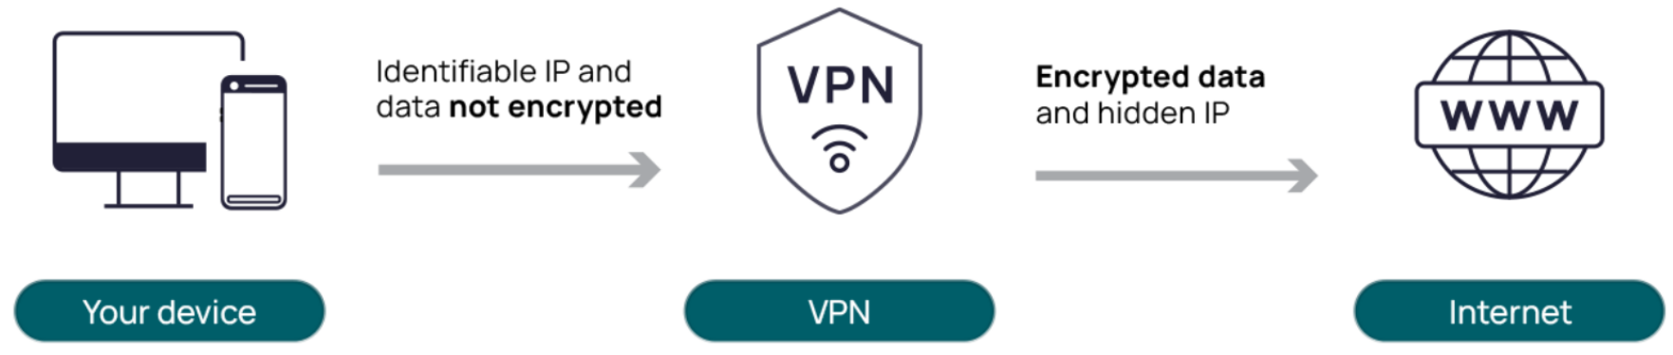

Fault Tolerant System
- Fault Tolerant system jo fail hone ke baad bhi kaam karta rahta hai.
- Ex. computer ke kisi part mein problem aa jaye (hardware, software, ya network), to bhi system band nahi hota aur apna kaam continue rakhta hai.
Backup Systems (Redundancy) & Data Copy (Replication)
Ex: Ek file ko cloud aur hard drive dono par save karna
Error Check
System problem ko automatic detect karta h aur usse thik karta h.
Failover (Backup System Auto On)
Agar main system fail hota h, to backup system khud on ho jata h
Graceful Degradation
system ka kuch part fail ho jaye, to basic features chalate rahe
Group of Servers
Ek system k liye Multiple servers hote h agar Ek fail hota h to doosra chal padta h
Load Sharing (Load Balancing)
Kaam ko multiple systems ke beech baat dete h
System Save Points (Checkpoints)
System apna kaam save karta h Agar fail hota h, to wahi se shuru hota h.
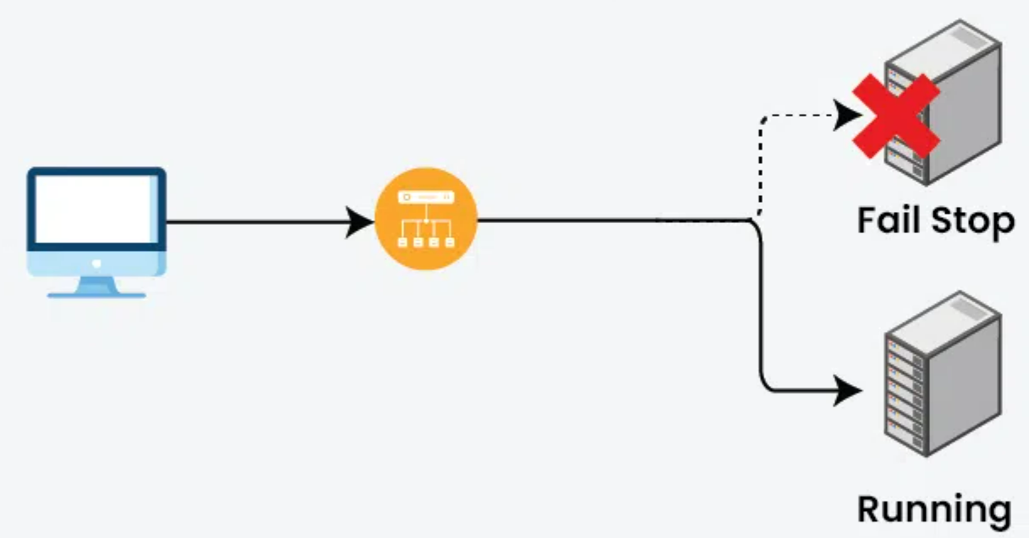

*In context to RAID, explain Mirroring, Duplexing, Striping with parity
Raid
- RAID ek technology hai
- data ko safe aur fast access karti h
- isme alag-alag methods hote hain jaise Mirroring, Duplexing aur Striping with Parity
1. Mirroring (RAID 1)
- data ki copy ko multiple drives par store karta h.
- Agar ek drive fail hoti h, toh doosri drive se data milta h.
- Yeh safe hai
- storage ka aadha part use karta h
2. Duplexing (Mirroring with extra controller)
- data ki copy ko multiple drives par store karta h.
- Agar ek drive fail hoti h, toh doosri se data milta h
- har drive ka alag controller hota hai.
- Agar ek controller fail hota h, toh doosra controller kaam aata h
- Mirroring se jyaadai safe aur mehenga h
3. Striping with Parity (RAID 5, RAID 6)
- data ko divide karke multiple drives par store kiya jata hai
- Stripping recovery ke kaam aata hai.
- RAID 5 ek drive fail hone k baad bhi kaam karta hai.
- RAID 6 do drive fail hone k baad bhi data recover kar sakta hai.
- Yeh speed aur safety ka balance rakhta h
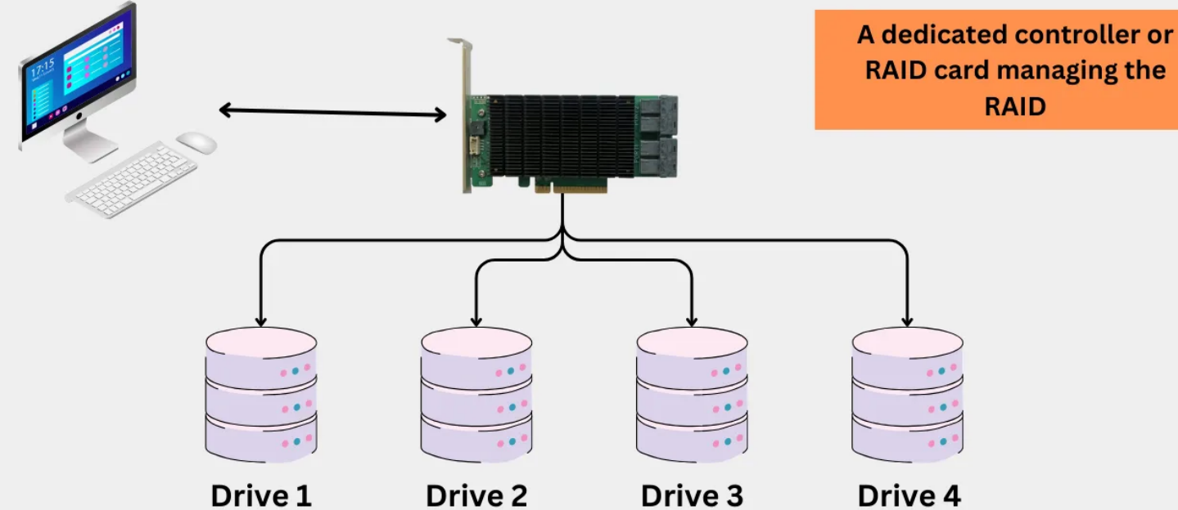

Discuss the file system in Windows-XP and also explain how the office file features in Windows-XP are enabled?
Windows XP Ka File System
Windows XP do tarah ke file systems use karta hai:
FAT32 aur NTFS
Office Files Ke Features:
Windows XP me Office files useful features:
- Password Lagana: files ko password se secure kar sakte hain.
- AutoSave: Agar system band ho jaye, toh files recover ho sakti hain.
- File Sharing:
- Compatibility Mode: Purani Office files bhi XP me open ho sakti h
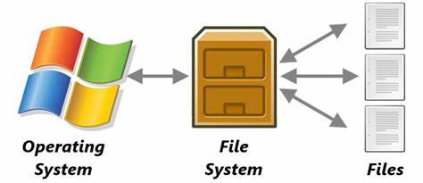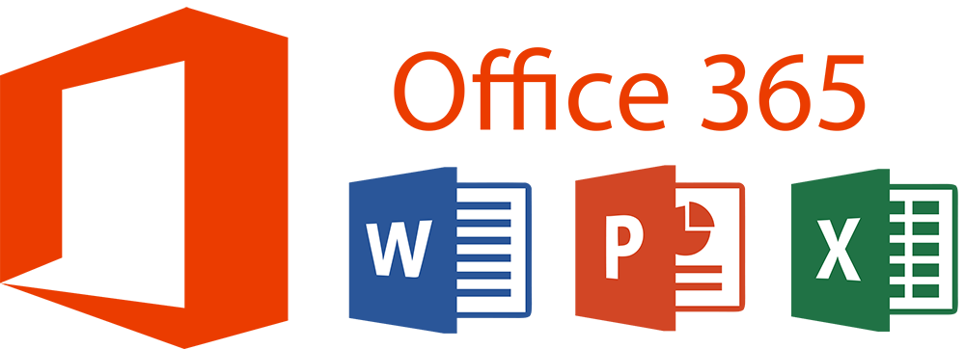

Discuss the absolute and relative pathnames in LINUX with the help of suitable examples for each
Path
- Linux me kisi bhi file ya folder tak pahunchne ke liye path ka use hota hai.
Do tarah ke path hote hain:
1. Absolute Path
- Absolute path full address hota hai,
- jaise "Delhi se Mumbai train ka pura route"
- root (/) se start hota hai jo Poora address batata hai
- Ex. /home/john/Documents/file.txt
2. Relative Path
- Relative path current location se jaana hota hai,
- jaise "Apne ghar se nearest bus stop tak ka rasta"
- Root / se start nahi hota h
- john/Documents/file.txt
- Special Shortcuts:
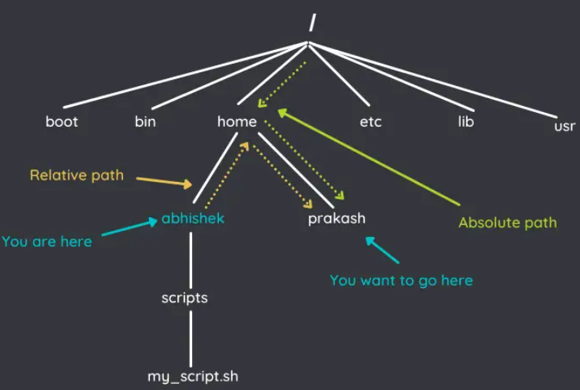

LINUX FILE OR DIRECTORY SYSTEMS
Linux file system
- Linux ka file aur directory system ek tree jaisa hota hai,
- Linux me sab kuch ek file ya folder ke roop mein hota h
- Lfs me Root direct. sabse starting wali directory hoti hai, jismein saari cheezein hoti hain.
- Example: /home, /bin, /usr
Important Folders (Directories)
- /bin → Important commands jaise ls, cp, mv yahan hote hain.
- /home → Har user ka personal folder hota hai, jaise /home/rahul.
- /etc → System ke settings aur configuration files yahan hoti hain.
- /var → Log files aur temporary data store hota hai.
- /dev – Yahan device files hote hain, jaise ki hard drive, USB, etc. (devices ko file jaisa treat kiya jata hai Linux mein).
- /tmp – Temporary files ke liye use hoti hai. System shutdown ke baad yeh files delete ho sakti hain.
- /usr/bin - Yeh directory user ke executable programs ko store karti hai
Special Files Ye thodi alag files hoti hain
- Device Files: Hardware ke liye, jaise disk ya terminal
- Pipes: Do programs ke beech baat karne ke liye
- Sockets: Network ke liye.
- Symbolic Links: Ek file ka shortcut
- Proc Files: System ki info ke liye
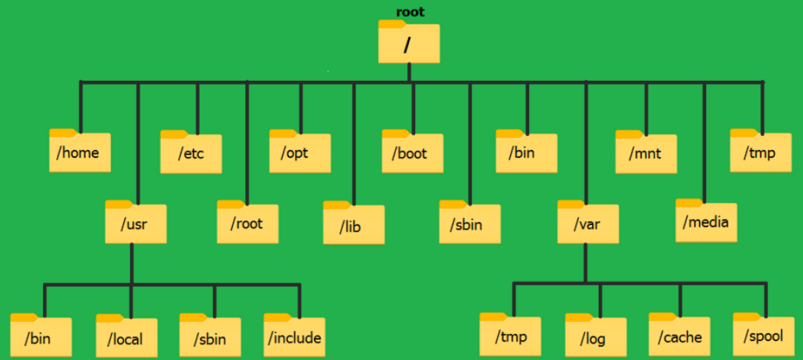

Differentiate the role and responsibilities of “user mode” and “kernel mode” of Windows-2000 system
Windows 2000 do tareeke se kaam karta hai: User Mode aur Kernel Mode.
Dono ka alag kaam hota hai.
Dono milke Windows 2000 ko secure aur smooth banate h
User Mode (Safe Zone)
- User Mode normal software aur apps chalane ke liye hota hai.
- User Mode k paas system ka direct control nahi hota
- User Mode me limited access hota hai.
- User Mode me jab app crash hoti hai to sirf wahi band hoti hai jisse pura system kharab nahi hota
- Examples: Chrome, MS Word, VLC Player.
- Security - high
Kernel Mode (Power Zone)
- Kernel Mode system ka main part hai jo hardware aur memory ko control karta hai.
- Kernel Mode k paas system ka poora control hota hai,
- Kernel Mode me unlimited access hota hai.
- Kernel Mode me agar kuch gadbad ho jaye to pura system crash ho sakta hai (Blue Screen of Death)
- Examples: Windows ka memory manager, device drivers, file system
- Security - weak
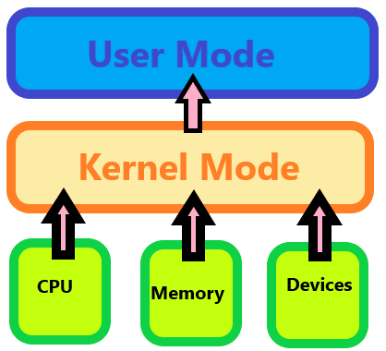

Types of network
LAN
- Area - Ghar, school, office jaise chhoti jagah
- Size - small
- Speed - fastest
- Device - switch, Wi-Fi, Router
- Uses - connect office computers
MAN
- Area - ek city ya bada shehar
- Size - medium
- Speed - Medium speed
- Device - router, fiber cables
- Uses - City ke multiple buildings connect karne ke liye
WAN
- Area - Desh ya duniya bhar
- Size - Big
- Speed - slow
- Device - Satellite, routers
- Uses - Alag-alag desh ya continents ko connect karne ke liye
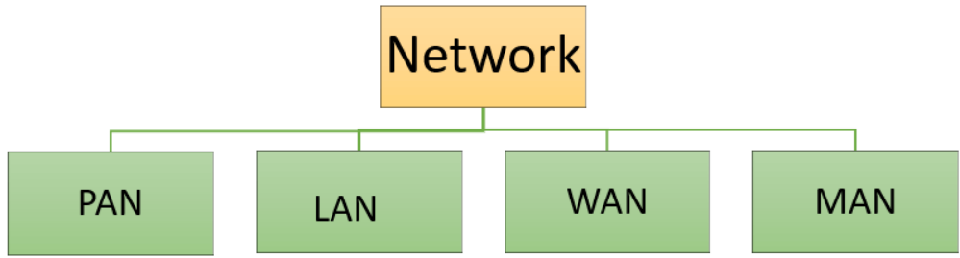

Discuss the following briefly w.r.t. Windows-2000:
(i) NTFS (New Technology File System)
(ii) EFS Services (Encrypting File System)
NTFS (New Technology File System)
- NTFS ek file system hai jo Windows 2000 me use hota hai.
- NTFS purane FAT32 se better hai
- NTFS zyada badi files store kar sakta hai
- NTFS ki security achhi hai, aur data ko safe rakhta hai.
- NTFS me file compression aur disk quota jaise extra features hote h
EFS Services (Encrypting File System)
- EFS (Encrypting File System) ek Windows feature hai
- files aur folders ko encrypt karta h aur secaurity badhata hai.
- EFS data ko safe rakhta hai
- EFS background me kaam karta hai, taaki user ko extra mehnat na karni pade.
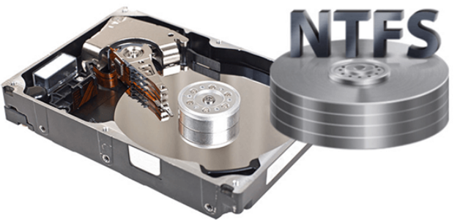

File Transfer Protocol (FTP):
- FTP ek network protocol hai
- FTP files ko ek computer se dusre computer me transfer karta h
- internet se files upload ya download karte h.
- FTP do channels ka use karta hai:
ek command bhejne ke liye aur doosra data transfer ke liye.
- FTP port 20 aur 21 ka use karta h
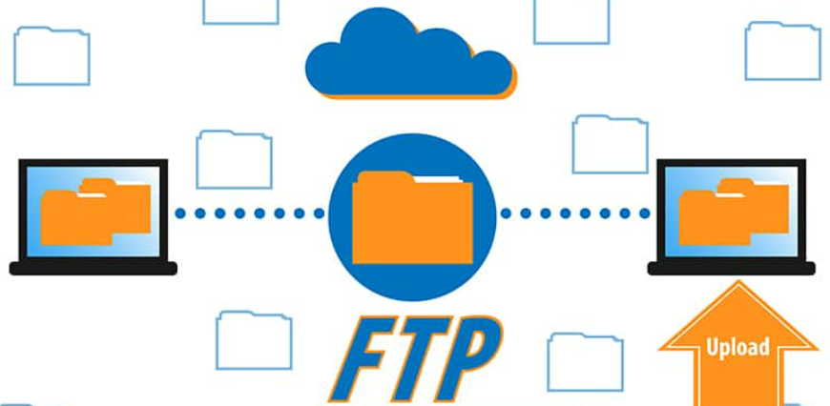

REAL TIME OPERATING SYSTEM
- RTOS time-bound tasks ko perform karta hai.
- RTOS har kaam ko ek fixed time limit ke andar complete karta h
- RTOS koi bhi task delay ke bina complete karta h.
- RTOS un jagahon par use hota hai jahan accuracy aur time dono important hote h
Applications of RTOS:
- Embedded Systems – jo washing machine, microwave me use hota h
(In devices mein kaam exact time pe hona chahiye.)
- Medical Systems – jaise pacemaker, patient monitoring systems
(Zara sa delay patient ki life ke liye dangerous ho sakta hai.)
- Industrial Automation – jaise robots aur machines in factories
(Har step ko proper timing se execute karna zaroori hota hai.)
- Automobile Systems – jaise airbags, ABS (Anti-lock Braking System)
(Accident situation mein turant response chahiye hota hai.)
- Telecommunication Systems – jaise network routers, switches
(Data ko time par bhejna aur receive karna hota hai.)

Briefly discuss the following network connecting devices, mentioning their purpose, operating layer and working principle:
REPEATERS
- Repeater Wifi k weak ya long-distance signals ko receive karke strong banakar bhejta h
- Repeater signal ki range ko badhata h
- repeater data loss ko kam karta h
HUB
- Hub bhot saare devices ko ek saath jodta hai
- Hub ek network banata hai.
- Hub ek baar me sab device ko data bhejta hai jisse traffic hota h
*ROUTER
- Alagalag networks ko connect karta h
- Network Layer (Layer 3) par kaam karta hai.
- IP address ke saath kaam karta hai
- LAN ko WAN ke saath jodne ke liye
- Thoda slow hota hai.
- Broadcast ko rokta hai
BRIDGE
- Ek hi network ke parts ko jodta hai
- Data Link Layer (Layer 2) par kaam karta hai
- MAC address ke saath kaam karta hai
- LAN ko expand ya divide karne ke liye
- Fast hota hai
- Broadcast ko aage bhejta hai

MODEM
- Modem ka full form hota hai Modulator-Demodulator.
- Modem digital signal ko analog signal mein convert karta hai aur fir wapas analog se digital mein.
- Modem computer ya mobile ko internet se connect karta h jaise telephone line, cable line ya wireless network ke through
Modem ke 4 types:
- Dial-up Modem:
Tech - old, telephone line se internet connect karta hai.
Internet Speed - very slow
- DSL Modem (Digital Subscriber Line):
Tech - Old, telephone line se internet connect karta hai.
Internet speed - fast, Internet use karte waqt phone call bhi kar sakte h
- Cable Modem:
Tech - Modern & popular, cable TV line se internet connect karta hai
Internet speed - high speed
- Wireless Modem:
Tech - latest & Modern Internet k liye wire ka use nahi karta h.
4G ya 5G jaise wireless network ka use karte h
Internet speed - super fast
Modem ke 4 features:
- Data Transfer:
Modem data ko send aur receive karne ka kaam karta hai.
- Speed:
Har modem ki alag speed hoti hai (Kbps ya Mbps mein).
- Compatibility:
Modem zyada tar operating systems aur devices ke saath compatible hote hain
- LED Indicators:
Modem par chhoti lights hoti hain jo internet status, power aur signal show karti hain.

Token Ring & Bus
- Ye ek network topology hai
- jisme devices ring ya (circle) ki form me connected hote hain.
- Data send karne ke liye ek device dusre doosre device ko token bhejta hai,
- Ex. lan
- jiske paas token hota hai wahi data bhej sakta hai.
Token Bus —
jisme devices bus (single communication line) ki form me connected hote hain.

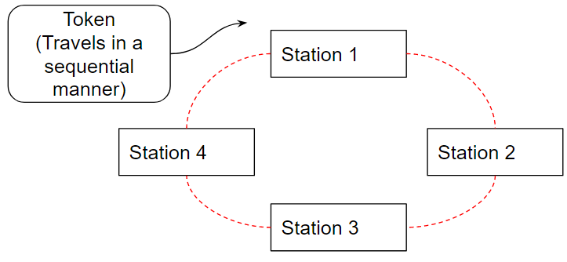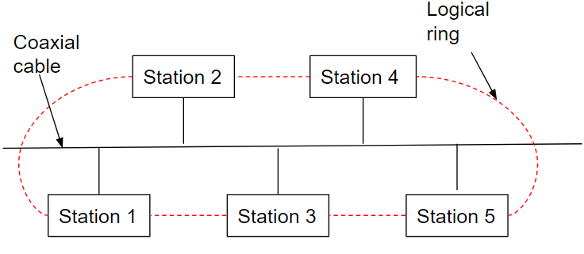
# | Features | TCP | UDP
1 | Connection | Connection-oriented (pehle connection) | Connectionless (seedha data)
2 | Reliability | Reliable (data safe aur sahi deliver hota hai) | Unreliable (data gum ho sakta hai)
3 | Speed | Slow (zyada checks ke wajah se) | Fast (kam rules, jaldi data)
4 | Ordering | Packets order mein aate hain | Order maintain nahi karta
5 | Use Case | Web, email, file transfer | Streaming, gaming, VoIP
6 | Acknowledgment (ACK) | Haan, har packet confirm hota hai | Nahi, koi confirmation nahi
7 | Header Size | Bada (20 bytes – zyada info) | Chhota
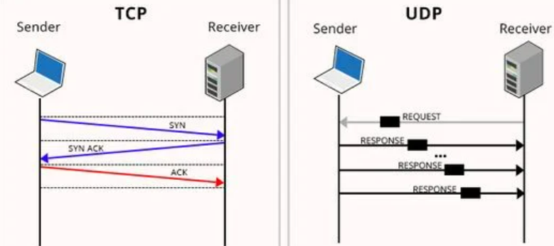

Users Administration in Windows 2000:
- Admin users ko system me add, password change, access permission, account control karta h
- Admin “Computer Management” aur “Active Directory”. K se naye user bana sakta h
- Ex. whatsgroup admin, windows admin, system admin
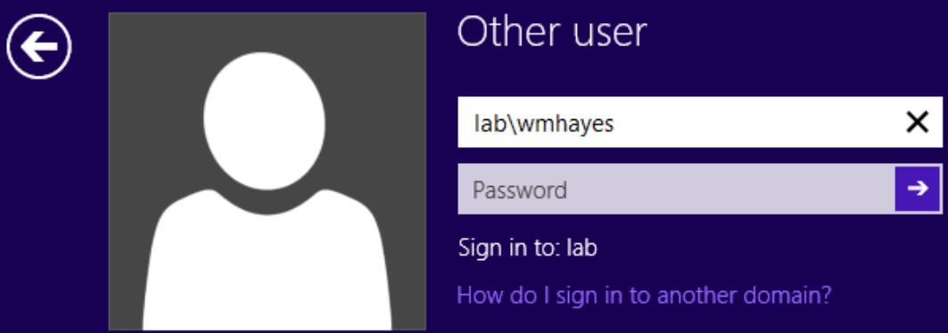

Managing User Profiles in Windows-2000
- Windows 2000 mein har user ka alag profile hota hai
- jisme unki settings aur files store hoti hain.
- Agar kisi ka roaming profile hai, toh woh kisi bhi computer se apni settings access kar sakta h
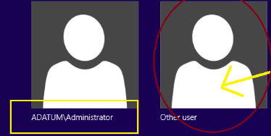

Peer-to-peer (P2P) network
- P2P me sabhi computers main server ke bina ek dusre se directly connected hote h
- Har computer dusre computer ko files, printers, aur internet share kar sakta h
- Windows 2000 P2P network ko support or suitable hai
- lekin bade networks ke liye Windows 2000 Server better ha
- Ex. P2P Chhoti offices ya ghar ke networks ke liye achcha hai, blutooth, hotsport
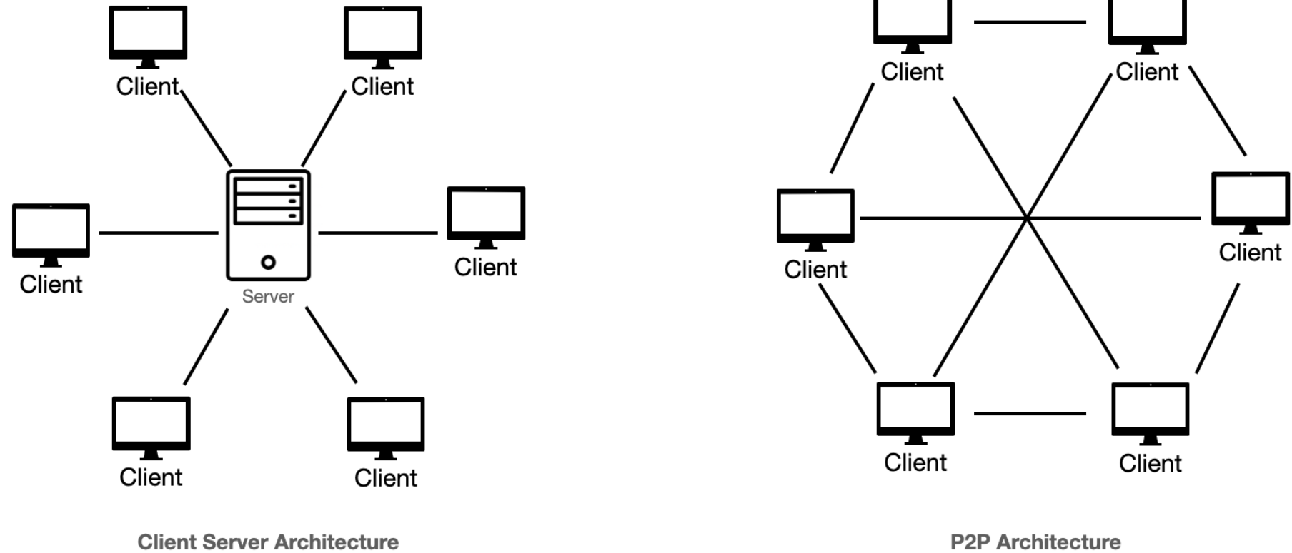

*Gateways Network Device
- Gateway ek network device hoti h
- jo do alag networks ko jodti h
- Yeh data ko convert karke ek network se dusre network tak pahuchata h
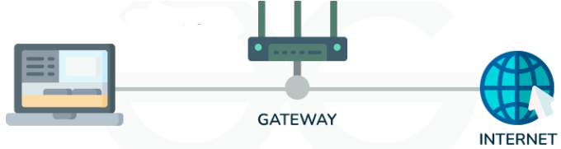

Backup aur Restoration in LINUX
- Linux mein data ka backup lene ke liye tar aur rsync jaise tools use hote hain.
- Backup - data ki copy banake rakhte h
- Restore - delete hue temprory data ko wapas lana
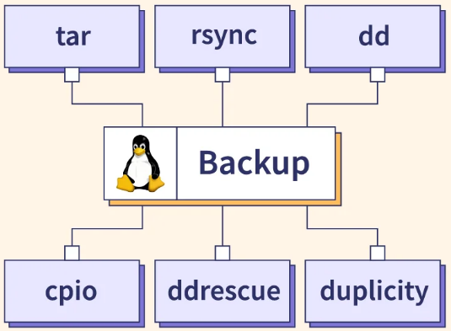

Distributed Operating System
- ek se zyada computers ko jodkar ek hi system ki tarah kaam karta hai.
- Isse computers ek dusre ke saath kaam kar sakte hain
- aur data share kar sakte h
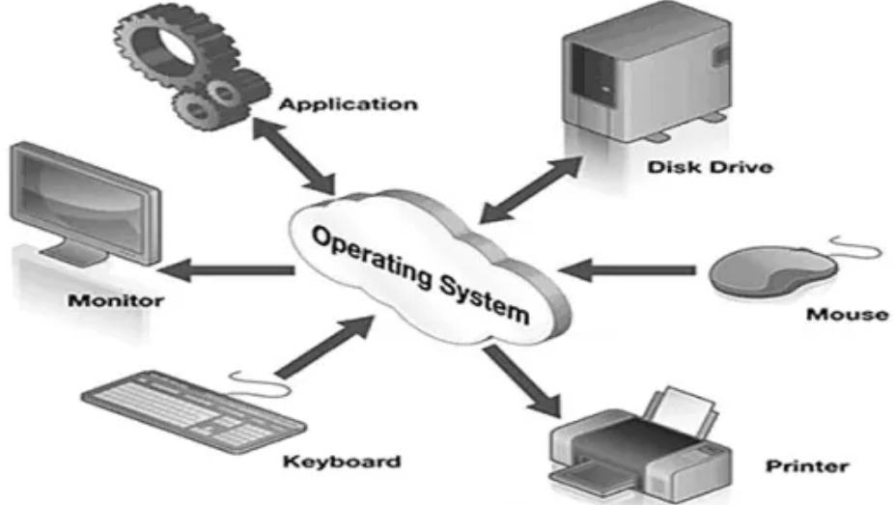

Client-Server Model
- ek network architecture hai
- jisme client request bhejta hai aur server us request ka response deta hai.
- Security - strong
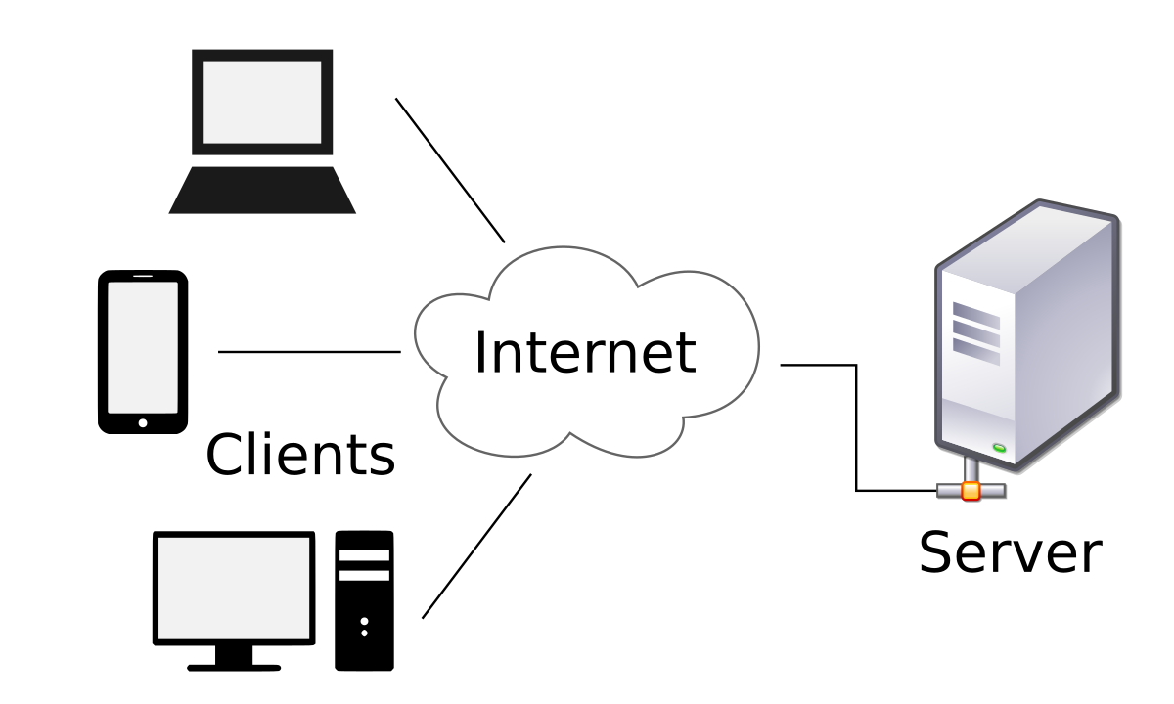

Physical Connection
- network devices k beech actual physical connection hota hai jese wires, cables
- Data ya signal ko ek network device se dusre network device par transfer kiya jata h
- Ex. topology, network towers, electricity meter
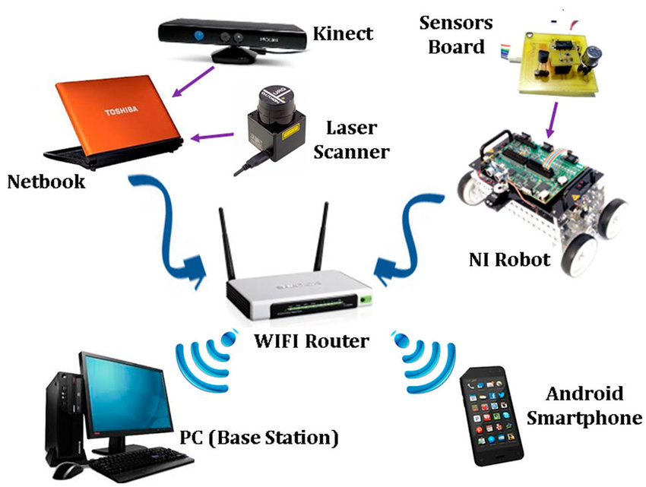

Linux mein user-to-user communication
- ek system me ek user doosre user se communication karne k liye `write`, `talk`, ya `msg` jaise tools ka use karta h
- users real-time mein ek doosre se baat karne ya messages bhej sakte h
- dono users ko Linux system ya server par hona jaroori h
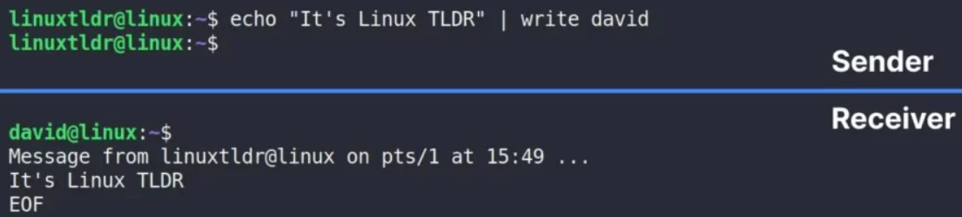

Goals of Computer security
- Confidentiality – Data sirf sahi log dekh sakein, galat log access na kar paayein.
- Integrity – Data bilkul sahi rahe, bina kisi chhed-chhad ke.
- Availability – Jab zaroorat ho, tab system aur data easily mil sake.
Ye teeno milke computer aur data ko safe rakhte hain.

IP Addressing
- IP address ek unique number hota h
- Ip address har device ko diya jata hai jo internet ya network se connected ho.
- Yeh number devices ko ek dusre se baat karne mein madad karta h
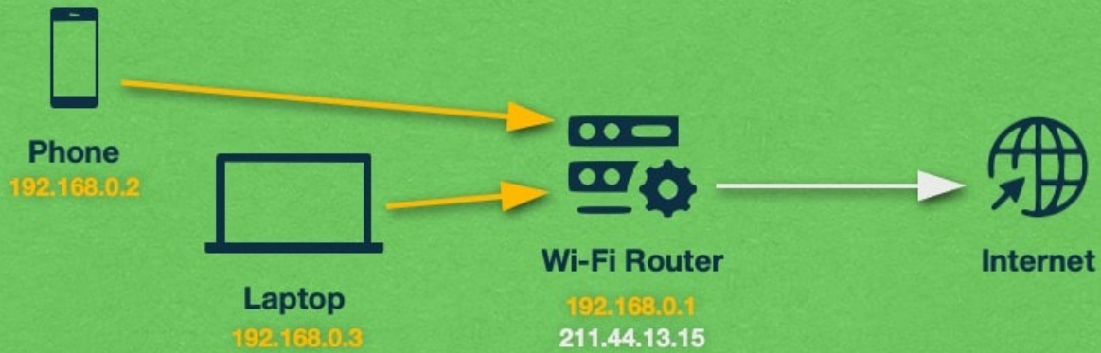

Intrusion Detection
jab koi bina permission k computer ya network mein ghusne ki koshish karta h to yeh alert deta h
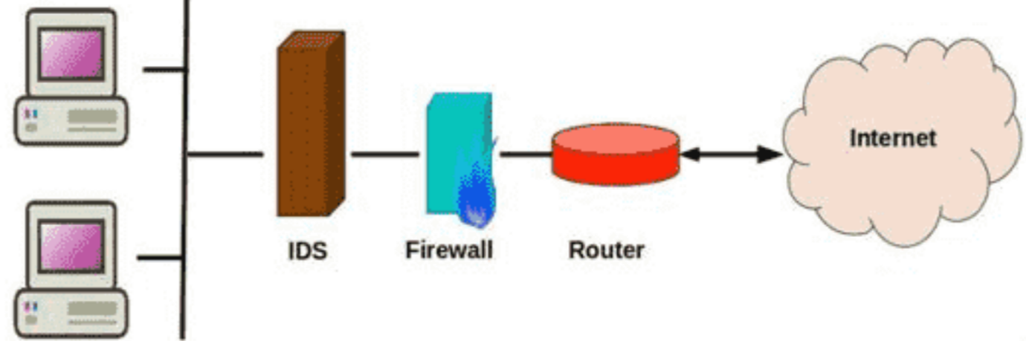

Remote Login
computer ko door se access karna
Tools - SSH ya RDP, anydesk


Proxy Server
- Bich ka computer hota hai jo client ki request ko internet tak pahunchata hai
- User ki privacy aur security badhata hai aur client ki identity ko chhupata h
- aur internet ko fast karta hai.
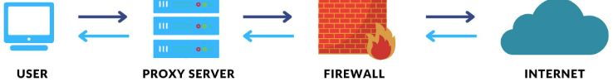

NFS
- Linux mein NFS (Network File System) ek protocol hota hai
- network par files ko ek system se dusre remote system par transfer/ share kiya jata h
- Ex. file by google, file manager
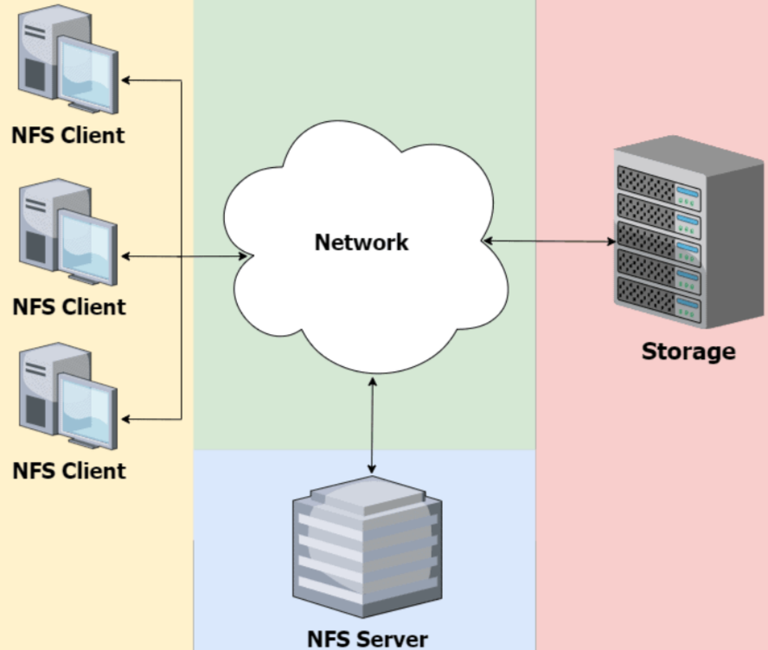

virtual memory
- rom se kuch space nikaal kar virtual ram banata h
- Physical ram k saath jud jaata h jisse ram increase hoti h
- Ex. zram, Dr.phone, swap
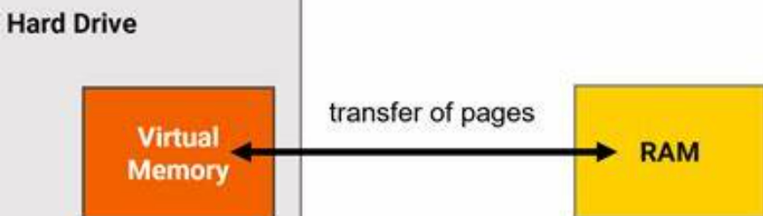

Serial Processing
- ek task ko complete hone k baad agla task start hota h
- Ek time par sirf ek task hota hai.
- Sp slow hota h kyunki 1 task complete hone me time lagta h
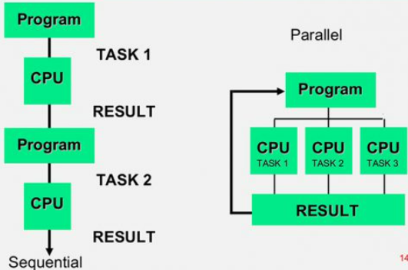

System Calls
- program aur operating system ke beech ka connection hota h.
- Ex. program ko file open karni ho ya data save karna ho
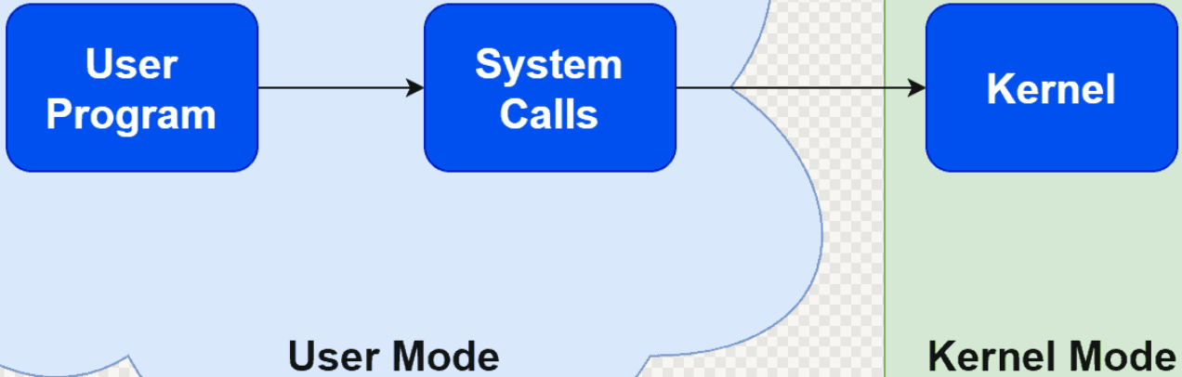

Virtual Machines
- local Machine k andar ek alag operating system chalaya jata hai
- Testing aur development ke liye useful hai.
- Ex. wsa, virtual box, vm ware
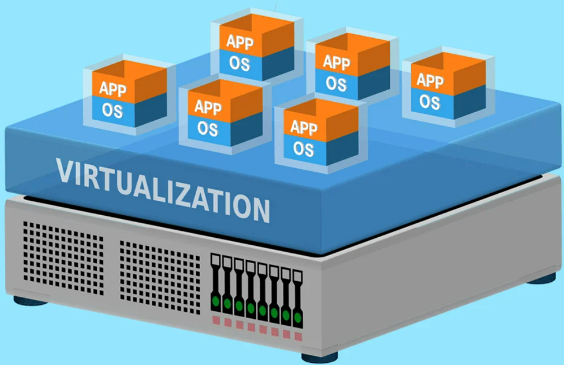

Cryptography:
- Cryptography data ko secret banata hai taki unauthorized log use samajh na sakein.
- Cryptography data ko encrypt karta hai aur sirf authorized log decrypt kar sakte hai
- Cryptography ka use data ko confidentiality, integrity, aur authentication k liye hota h


IPSec Framework:
- ek security protocol hai
- jo internet par data ko encrypt karke securely transfer karta h
- IPSec mainly VPN (Virtual Private Network) me use hota hai
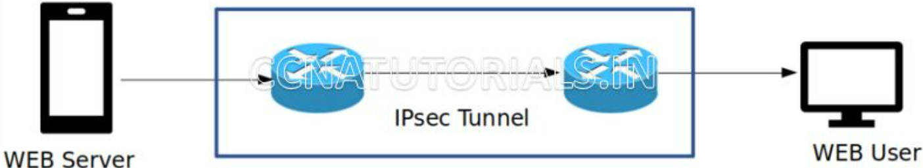

Memory Management
- Linux ki ram or ram ko manage ya organise kiya jata h
- system ki RAM ko efficiently allocate aur manage karta hai taaki har program ko zarurat ke mutabik memory mil sake
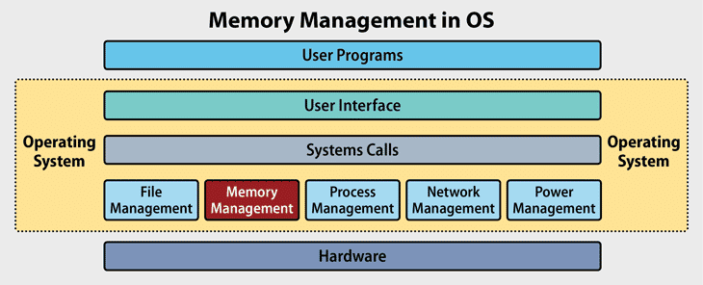

GUI
- Graphical User Interface (GUI) se user computer ya software ko aasani se chala sakta h graphics dekh k
- Gui me graphics, animations, images, icons, symbols, buttons aur menus hote hai.
- Gui se user mouse ya touch se easily click karke kaam karta hai.
- Ex. Jaise kisi file ko open karne ke liye icon par click karna.
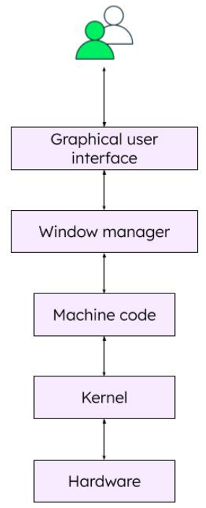

Spooling
- Spooling ek process hai jisme data ko temporarily ek buffer ya hard disk mein store kiya jata h jisse devices (jaise printer) sequentially process hote h
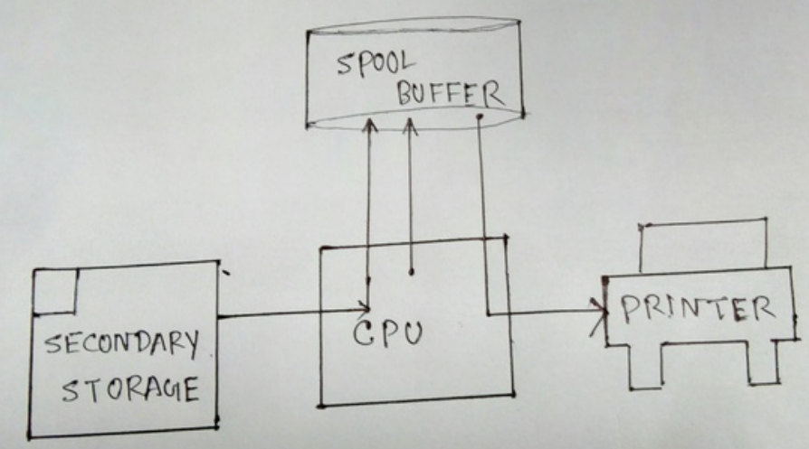

Windows NT Registry
- ek central database hota hai jo system settings, hardware, software aur user configuration ki information store karta hai.
- Windows NT Registry ek database hai
- computer ke functions ko smooth banata hai.

Process in Linux:
- Process ek running program hota hai.
- Har process ka apna ID hota hai (PID).
- Linux decide karta hai kaunsa process chalega — isse scheduling kehte hain
- Ek time par cpu ek hi process use karta hai aur baaki wait karte hain.
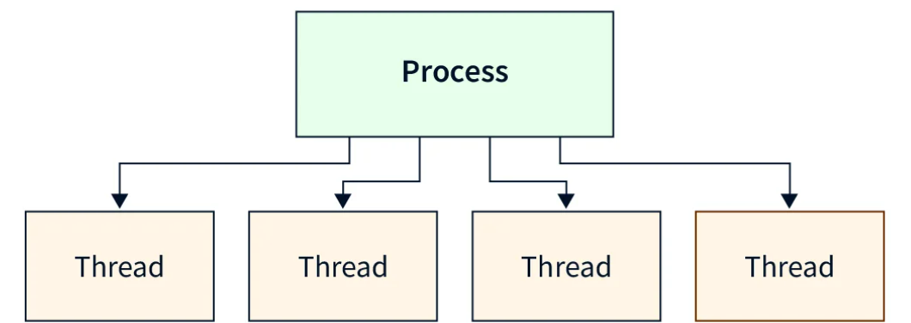

Thread in Linux:
- process ke andar chhoti unit hoti hai.
- Threads same memory share karte hain — isliye fast hote hain.
- Har thread ka apna kaam hota hai, lekin sab ek hi process mein hote hain.
- Thread banane ke liye pthread_create() use hota h
- ps, top, htop – Process dekhne ke liye
- kill – Process band karne ke liye


Features of Linux
1. Free 2. Open Source 3. Customizable 4. Multi-User
5. Multitasking 6. Secure 7. Stable

Filters
Linux mein filters aise commands hote hain jo input data ko process karke modified output dete hain, jaise grep, sort, uniq, cut, aur awk.
Pipelines
Linux mein Pipelines ek technique hoti hai jismein ek command ka output directly doosri command ke input mein diya jata hai using | (pipe) symbol
ls | grep "f.txt"
*redirection
Linux mein redirection commands ka use hota hai output ko file mein ya input ko file se lene ke liye.
ls > files.txt
wc < files.txt

Mandatory Access Control
Windows 2000 mein system khud decide karta hai ki kaun kis file ya resource ko access kar sakta hai, user isme change nahi kar sakta.
Discretionary Access Control
Windows 2000 mein file ya folder ka malik decide karta hai ki kaun usse use kar sakta hai.

Packet Filtering
incoming aur outgoing data packets ko unke headers (IP address, port, protocol) ke basis par allow ya block karti hai.
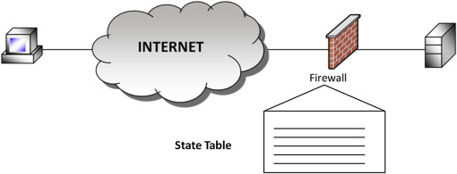

*Kerberos
- ek network authentication protocol hai
- client aur server ke beech securely identity verify karta hai
- bina password directly bheje. Ex. passkey

Discuss the following (giving an example for each) with reference to shell scripting in LINUX :
(i) Variables
- Variables data store karta hain
- Variables mein numbers, command output, ya user input (like read) bhi daal sakte h
- Variable define karne ke liye = use karte h
- Variable ko access karne ke liye $ lagate h.
- Example:
naam="Rahul" # Variable banaya
echo "Hello, $naam bhai!" # Variable use kiya
Output: Hello, Rahul bhai!
(ii) if ... else Statement
if ... else statement condition check karta hai aur uske hisaab se code run karta hai. Condition ke liye test ya [ use karo.
Ex.
umar=20
if [ $umar -gt 18 ]; then
echo "Tu adult hai bhai."
else
echo "Tu abhi chhota hai."
fi
Output: Tu adult hai bhai.
(iii) echo Command
- echo command terminal pe text dikhata hai.
- Echo command Messages, variable values, ya results dikhane ke liye use hota hai.
- Ex
salaam="Namaste, Duniya!"
echo $salaam # Variable ka value dikhao
Output: Namaste, Duniya!
(iv) break and continue
- break loop se poora bahar nikal deta hai
- continue current iteration skip karke next pe chala jata hai.
- Break aur continue for ya while loops mein zyada use hota hai.
- Example:
for i in {1..5}; do
if [ $i -eq 3 ]; then
continue # 3 pe skip karo
fi
if [ $i -eq 5 ]; then
break # 5 pe loop se bahar niklo
fi
echo "Number: $i"
done
Output:
Number: 1
Number: 2
Number: 4 #Yahan continue ne 3 ko skip kiya, aur break ne loop 5 pe rok diya.

Batch processing
Batch processing ek technique hai jisme kai tasks ya programs ek saath group mein execute kiye jaate hain bina user ke interaction ke.

Multimedia os
Multimedia OS ek aisa operating system hota hai jo audio, video, animation jaise multimedia content ko efficiently process aur manage karne ke liye design kiya gaya hota hai.

csma/ cd

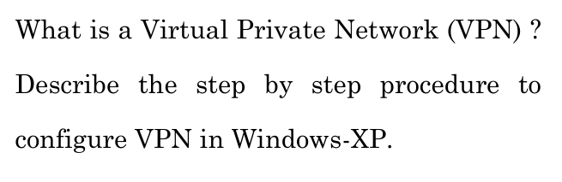
Windows XP Mein VPN Kaise Set Karein?
- Control Panel Open Karein:
  - Start button dabayein → Control Panel open karein.
  - Network Connections par click karein.
- Naya Connection Banayein:
  - Create a new connection pe click karein.
  - Next dabayein
- VPN Option Choose Karein:
  - Connect to the network at my workplace select karein.
  - Next dabayein.
  - Virtual Private Network connection choose karein.
  - Next dabayein.
- VPN Ka Naam Likhein:
  - Koi bhi naam daal sakte hain, jaise "My VPN".
  - Next dabayein.
- Server Address Likhein:
  - VPN ka server address ya IP address enter karein (jo aapke VPN provider ne diya hai).
  - Next dabayein.
- Setup Complete Karein:
  - Finish button dabayein.
- VPN Se Connect Karein:
  - Desktop pe VPN shortcut open karein.
  - Username aur Password daal kar Connect button dabayein.
Aapka VPN ab connect ho chuka hai! 🚀 Aap securely internet use kar sakte hain.


Ch 1. VPN Protocol Chuno
- Decide karo kaunsa system use karna hai, jaise:
  - OpenVPN: Secure aur flexible.
  - WireGuard: Fast aur lightweight.
2. Server Banao
- Apna server setup karna hoga:
  - Cloud services (AWS, Google Cloud, DigitalOcean) use karo.
  - Ya apne ghar ka computer ya router use karo.
- VPN software download aur install karo, jaise OpenVPN ya WireGuard.
3. Server Setup Karo
- Server software install karne ke baad:
  - Zaroori settings configure karo, jaise IP range aur security options.
  - Apne router par ek port open karo (OpenVPN ke liye port 1194).
4. Users Ke Liye Setup Karo
- User ke liye credentials banao, jaise username/password ya certificates.
- Ek configuration file banakar users ko do.
5. Client Install Karo
- Apne device par VPN client software install karo (e.g., OpenVPN app).
- Configuration file use karke connect karo.
6. VPN Test Karo
- Check karo ki VPN properly kaam kar raha hai:
  - Website jaake IP address change hone ka confirm karo.
  - Dekho ki aap restricted content access kar paa rahe ho ya nahi.
7. Secure Rakho
- VPN software ko updated rakho.
- Unauthorized access rokne ke liye server logs check karo.

Dec 2022 checked
June 2023 checked
Dec 2023 checked
June 2024 checked
Dec 2024 checked

Notes by Ankit Kumar
9389715277

